Aim: Installation and basic of Android Studio & Flutter with implementation of “Hello World”.

Theory:

Q1. What is Mobile App Development?
It is the process of creating software applications that run on mobile devices. Developer’s design, code, test, and deploy apps for platforms like iOS and Android, ensuring functionality and user engagement.

Q2. What is different type of mobile app?
- Native Apps: Built for a specific platform (e.g., Swift for iOS, Kotlin for Android).
- Web Apps: Accessed via browsers, not installed.
- Hybrid Apps: Combine web and native technologies (e.g., using Cordova).

Q3. What is Android Studio and its Feature?
Android Studio is the official IDE for Android development. Key features include:
- Intelligent code editor
- Visual layout editor
- APK analyser
- Built-in emulator
- Fast build tools

Q3. What is AVD?
AVD (Android Virtual Device) is an emulator that mimics real Android devices. It allows developers to test apps on various virtual screen sizes, orientations, and Android versions without physical hardware.

Q5. What is Flutter and its Feature?
Flutter is Google’s UI toolkit for building natively compiled apps from a single codebase. Features:
- Hot reload for quick updates
- Widget-based architecture
- Cross-platform (iOS, Android, web)
- High performance

Q6. Installation steps of Android Studio?
- Download Android Studio from the official Android Developer website.
- Run the installer and select required components such as Android SDK and Emulator.
- Follow the setup wizard and accept license agreements.
- Complete installation and launch Android Studio.
- Configure SDK Manager and download necessary SDK packages.
- Create or configure an Android Virtual Device (AVD) for app testing.
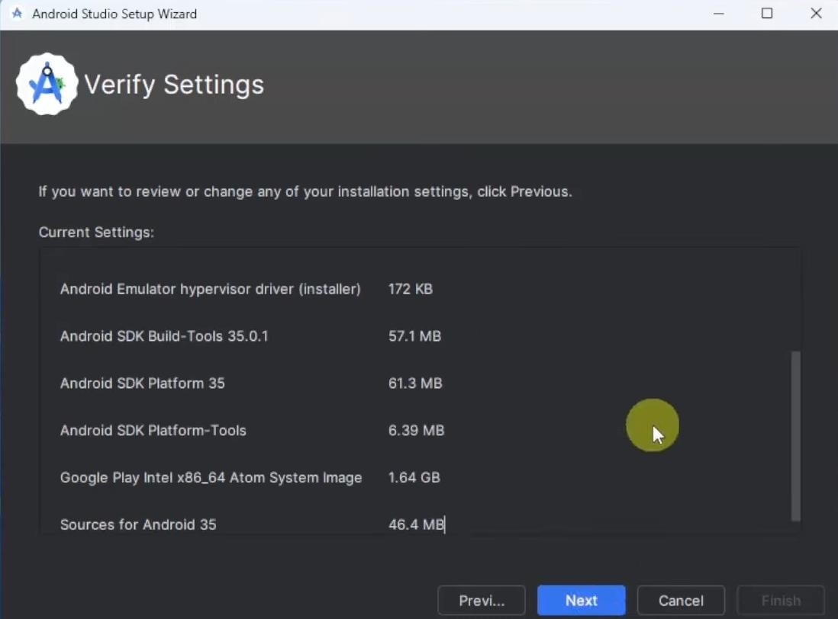
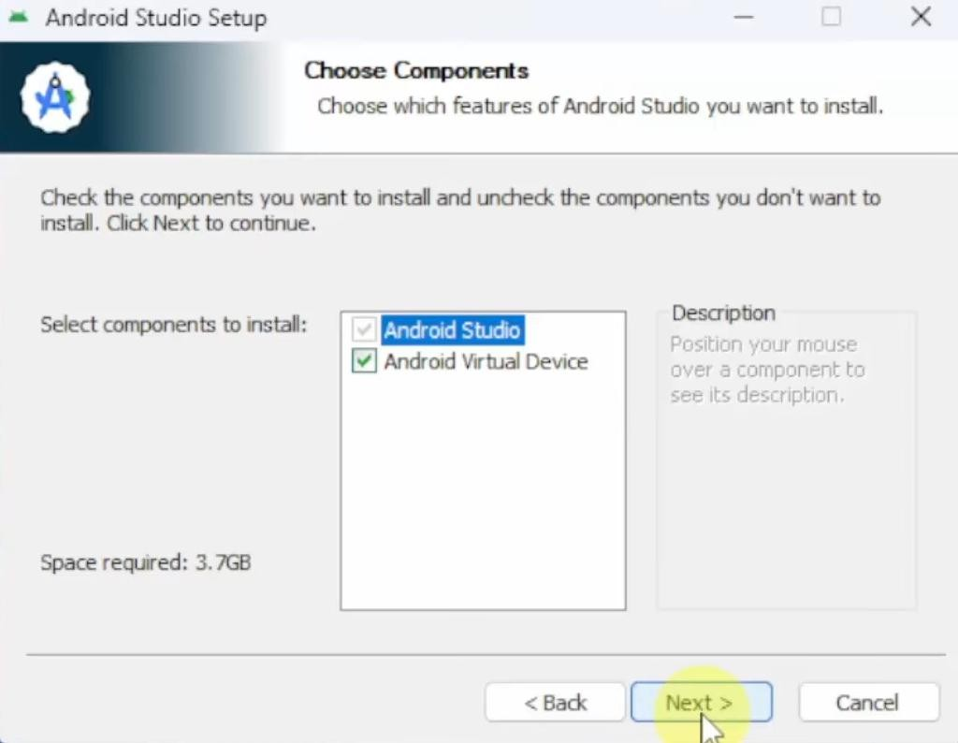
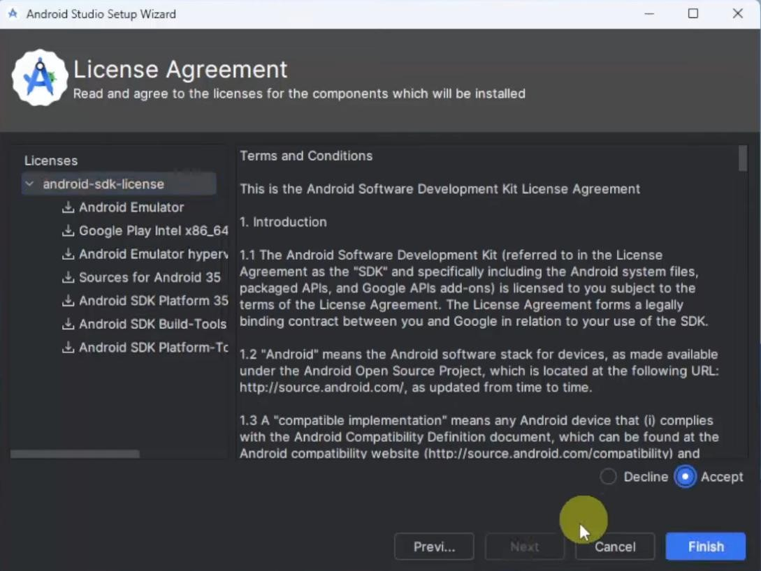

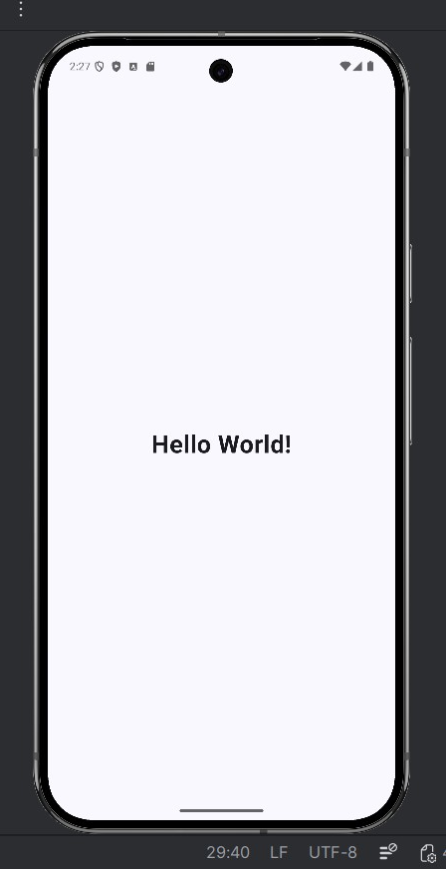
Q7. Implementation of “Hello World” with output?
MainActivity.kt:
class MainActivity : ComponentActivity() {
override fun onCreate(savedInstanceState: Bundle?) {
super.onCreate(savedInstanceState)
enableEdgeToEdge()

setContent {
HelloWorldTheme {
Scaffold(
modifier = Modifier.fillMaxSize()
) { innerPadding ->
Greeting(
name = "World",
modifier = Modifier.padding(innerPadding)
)
}
}
}
}
}

@Composable
fun Greeting(
name: String,
modifier: Modifier = Modifier
) {
Text(
text = "Hello $name!",
fontSize = 32.sp,
fontWeight = FontWeight.Bold,
modifier = modifier
.fillMaxSize()
.wrapContentSize(Alignment.Center)
)
}

Conclusion:
This experiment helped in understanding the basics of mobile app development, Android Studio, Flutter, and emulator usage. Implementing the “Hello World” application provided hands-on experience with the development environment and laid a strong foundation for building more advanced mobile applications in future experiments.

